2020

## Goals and Objectives

**Book Review System**

The goal of this project is to implement an online book review app which can be used to review on a book with the views of the reader. The goal is to achieve 2 types of user’s admin as well as the normal user. Every User Can edit, delete and add reviews on book.

## Project Scope

This is a 20 days project in which I have implemented an online book review website as INTO BOOKS. The scope of this project is to write review on books which a customer read on. And to rate the book. New user can register themselves to the application and start making review on what they read.

## Project Deliverables

This project will require certain deliverables. The table below outlines these deliverables.

|  |  |
| --- | --- |
| **Deliverable** | **Description** |
| Final Report | This document introduces the project and explains its details and requirements. Also states the milestone, schedule, hardware and software requirement and other important details. |
| Executable Programme | This will be the executable code of the project. |
| User Documentation | This will show how one can use the web application |
| Test Plan | This will provide the test detail of the project |

## Project Specifications

* Secure log in and registration
* Users Can add review on books which they read
* Can edit, delete the books and review.

## Target Audience

This website is to target all the book lovers over anywhere with whatever langue. It’s for every human begin without age limit.

## Project Tasks and Milestones

|  |  |  |  |  |  |  |  |  |  |  |  |  |  |  |  |
| --- | --- | --- | --- | --- | --- | --- | --- | --- | --- | --- | --- | --- | --- | --- | --- |
| Project Stages | Major Activities | Week1-2 | | | | Week-2-3 | | | | | Week-3-4 | | | | |
| Planning | Technology Research |  |  |  |  |  |  |  |  |  |  |  |  |  |  |
| Kick off Meeting |  |  |  |  |  |  |  |  |  |  |  |  |  |  |
| Project Proposal |  |  |  |  |  |  |  |  |  |  |  |  |  |  |
| Proposal Documentation |  |  |  |  |  |  |  |  |  |  |  |  |  |  |
| Execution – 1 | Database Design |  |  |  |  |  |  |  |  |  |  |  |  |  |  |
| User Interface Design |  |  |  |  |  |  |  |  |  |  |  |  |  |  |
| Identity Framework implementation |  |  |  |  |  |  |  |  |  |  |  |  |  |  |
| User Interface Implementation |  |  |  |  |  |  |  |  |  |  |  |  |  |  |
| Admin Interface Implementation |  |  |  |  |  |  |  |  |  |  |  |  |  |  |
| Testing |  |  |  |  |  |  |  |  |  |  |  |  |  |  |
| Closing | Final Documentation |  |  |  |  |  |  |  |  |  |  |  |  |  |  |

## Project Risks

The following are the identified high-level risks that might affect the completion and success of the project:

* Project delays may cause cascading delay in other dependent tasks.
* Project scope and duration may be underestimated.
* Project must have exceptional security for the system contains confidential information.
* The overall functionalities requested may be beyond what the developer can deliver in the given time available.

## Resource Requirements

Followings are the technologies and development method:

* 64-bit Processor and 4 GB RAM
* Asp.net MVC Framework
* Identity framework- ASP
* Windows Operating System

# Software Project Report

## Analysis

### Requirements Analysis

The requirement analysis covers the functional and non-functional aspects of the system.

#### Functional Aspects

The functional requirements of this project is divided into types. One for Authors, and one for Printers.

|  |  |
| --- | --- |
| **Users** | **Functional Requirements** |
| **User** | * Can review books * Add, Delete and Edit Books |

#### Non-Functional

|  |  |
| --- | --- |
| **Operational** | * The system should able to run on all web browsers. * The system should be accessible via mobiles |
| **Performance** | * The system should have a 99% uptime |
| **Security** | * Registered Users Can only do changes |

**Project Testing**

**System Usability Testing**

**Tester 1**

|  |  |  |  |  |  |  |
| --- | --- | --- | --- | --- | --- | --- |
| **Tester – 1** | | **Answer Scale** | | | | |
| **No.** | **Question** | **Strongly Disagree (1)** | **Disagree (2)** | **Normal (3)** | **Agree (4)** | **Strongly Agree (5)** |
| 1 | I think that I would like to use this system frequently |  |  |  |  |  |
| 2 | I found the system unnecessarily complex |  |  |  |  |  |
| 3 | I thought the system was easy to use |  |  |  |  |  |
| 4 | I think that I would need the support of a technical person to be able to use this system |  |  |  |  |  |
| 5 | I found the various functions in this system were well integrated |  |  |  |  |  |
| 6 | I thought there was too much inconsistency in this system |  |  |  |  |  |
| 7 | I would imagine that most people would learn to use this system very quickly |  |  |  |  |  |
| 8 | I found the system very cumbersome to use |  |  |  |  |  |
| 9 | I felt very confident using the system |  |  |  |  |  |
| 10 | I needed to learn a lot of things before I could get going with this system |  |  |  |  |  |

**Wireframe, prototype and the Original designs of the project**

**Home page**

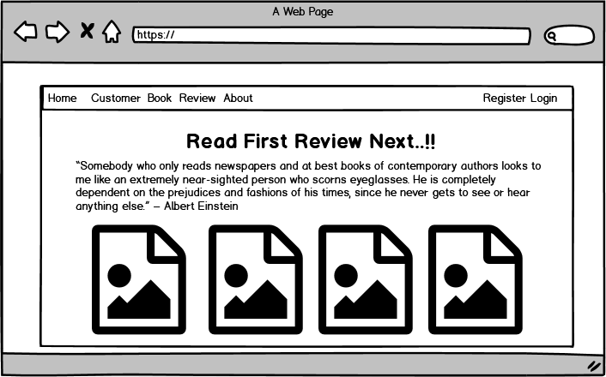

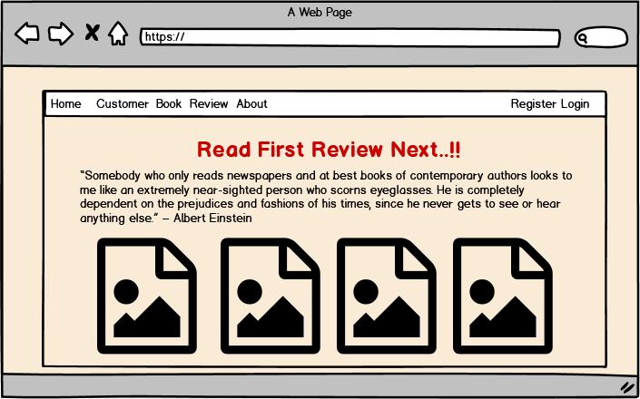



**Register Page**

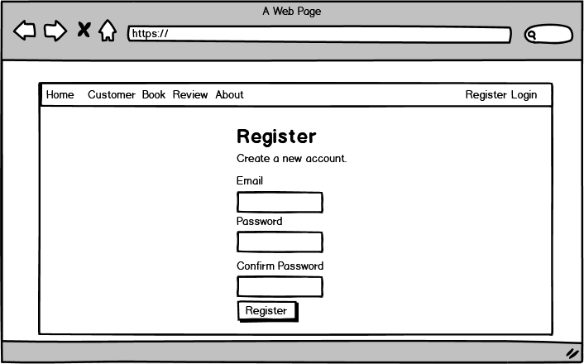

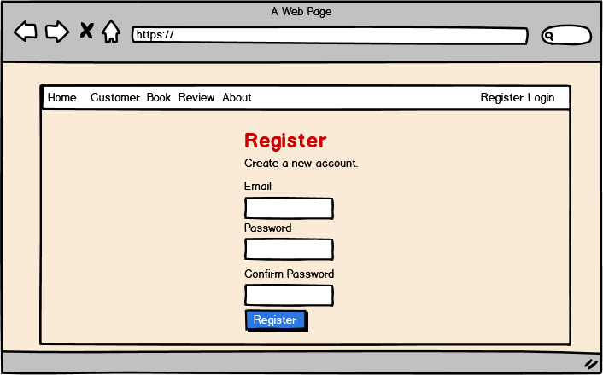

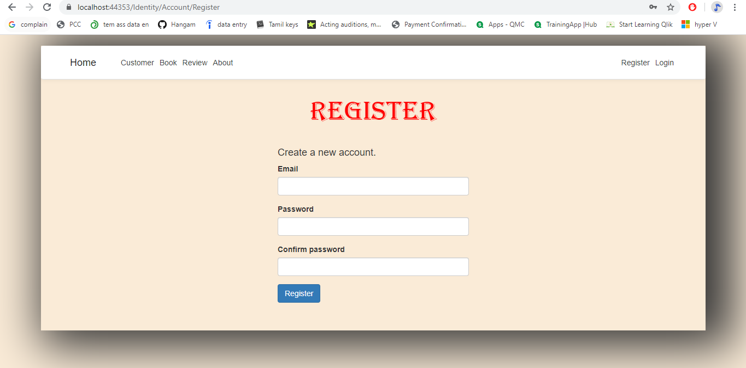

Login Page

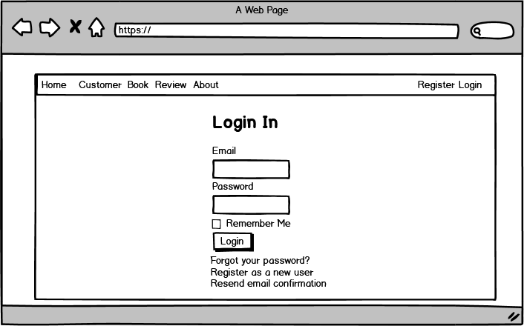

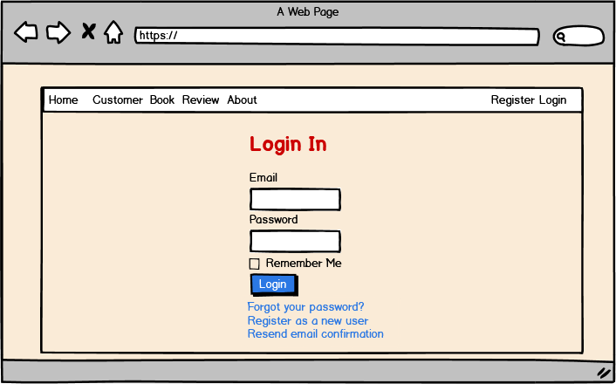

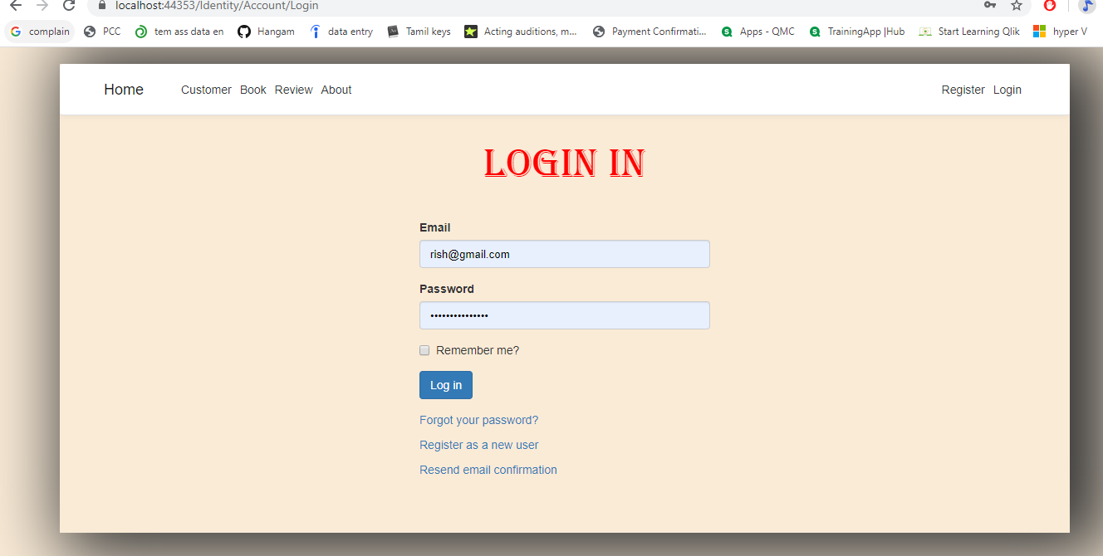

**Book Table Page**

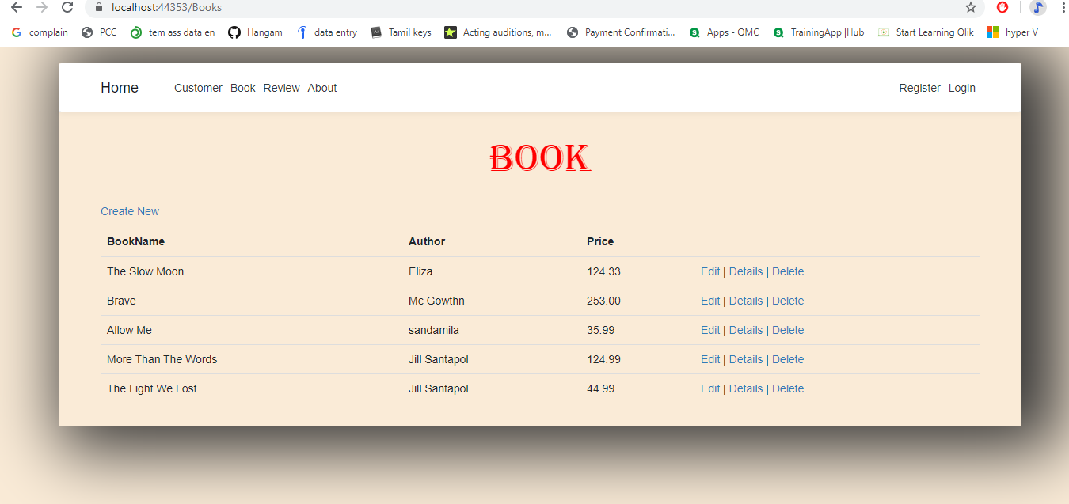

**Book Create Page**

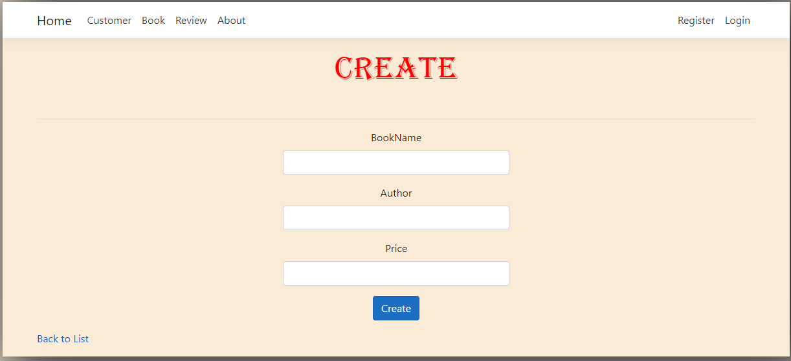

**Book Delete**

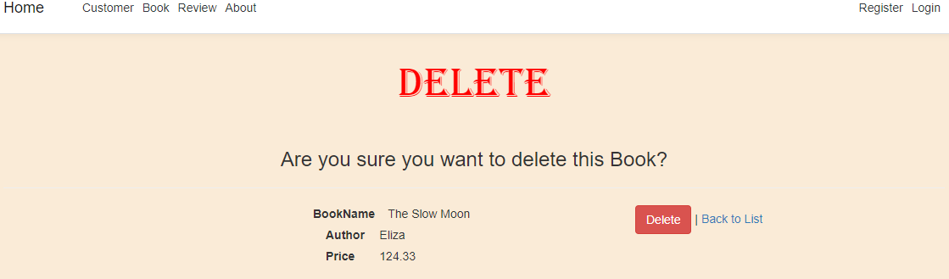

**User Manual**

**Quick Setup Guide**

**User Setup**

As a web application, there is no need of any special setup for the targeted users. However, there is need to register through the website to access its features. The web application is accessible through local host.

To register, simply click on the “Register!” on the Log In page. If you already have an account click on the “Login”

Once you login you will get into the access for all tables (Customer, Books, and Review).

## Future Work

I have tried to add Identity framework in order to achieve the Login, Register function those I implemented in the wireframe and prototype when though I faced lots of challenges and I couldn’t able to fix them in the real website. The major cause that I had problem with fixing is the time. So that in future I will go through the necessary steps to fix them and implement a project with all sources.

## General Information

## System Overview

It is a digital application where users can write review on books. In this application a user can add books. When a person login they can edit, add and delete. Also can view the detail of books and customers as well as review.

## System Summary

### System Configuration

Digital App is a web application developed using Asp.net MVC Framework. It will run on most modern web browsers and will not require any special system configuration. As a web application, it will require internet connection to function.